TEST PLAN
SWAG LABS

1 INTRODUCTION
Customer wants a perfect website, which passed the full cycle of manual testing. Given the
specificity of the site it is very important to have the same quality and the site.
The Test Plan has been created to facilitate communication within the team members. This
document describe approaches and methodologies that will apply to the unit, integration
and system testing of the " https://www.saucedemo.com/". It includes the objectives, test
responsibilities, entry and exit criteria, scope, schedule major milestones, entry and exit
criteria and approach. This document has clearly identified what the test deliverables will
be, and what is deemed in and out of scope.

2 SCOPE
The document mainly targets the GUI testing and validating data in report output as per
Requirements Specifications provided by Client.
2.1 Functions to be tested.
x GUI
x Search and Filters Logic
Login
Payment
Cart
Category

3 QUALITY OBJECTIVES
3.1 Primary Objectives
A primary objective of testing is to: assure that the system meets the full requirements,
including quality requirements (functional and non-functional requirements) and fit
metrics for each quality requirement and satisfies the use case scenarios and maintain the
quality of the product. At the end of the project development cycle, the user should find
that the project has met or exceeded all of their expectations as detailed in the
requirements.

Any changes, additions, or deletions to the requirements document, Functional
Specification, or Design Specification will be documented and tested at the highest level
of quality allowed within the remaining time of the project and within the ability of the test
team.

3.2 Secondary Objectives
The secondary objectives of testing will be to: identify and expose all issues and
associated risks, communicate all known issues to the project team, and ensure that all
issues are addressed in an appropriate matter before release. As an objective, this requires
careful and methodical testing of the application to first ensure all areas of the system are
scrutinized and, consequently, all issues (bugs) found are dealt with appropriately.

4 TEST APPROACH
The approach, that used, is Analytical therefore, in accordance to requirements-based
strategy, where an analysis of the requirements specification forms the basis for planning,

Test Plan
4 estimating and designing tests. Test cases will be created during exploratory testing. All
test types are determined in Test Strategy.
Team also must used experience-based testing and error guessing utilize testers' skills and
intuition, along with their experience with similar applications or technologies.

The project is using an agile approach, with weekly iterations. At the end of each week the
requirements identified for that iteration will be delivered to the team and will be tested.
Role | Staff Member | Responsibilities
Project  Manager |  | 1. Acts as a primary contact for development and QA  team.  2. Responsible for Project schedule and the overall  success of the project.
QA Lead |  | 1. Participation in the project plan creation/update process.  2.Planning and organization of test process for the release.  3.Coordinate with QA analysts/engineers on any  issues/problems encountered during testing.  4.Report progress on work assignments to the PM
QA |  | 1. Understand requirements  2. Writing and executing Test cases  3. Preparing RTM  4. Reviewing Test cases, RTM  5. Defect reporting and tracking  6. Retesting and regression testing  7. Bug Review meeting  8. Preparation of Test Data  9. Coordinate with QA Lead for any issues or problems  encountered during test preparation/execution/defect  handling.

6 ENTRY AND EXIT CRITERIA
6.1 Entry Criteria
x All test hardware platforms must have been successfully installed, configured, and
functioning properly.
x All the necessary documentation, design, and requirements information should be
available that will allow testers to operate the system and judge the correct behavior.
x All the standard software tools including the testing tools must have been
successfully installed and functioning properly.
x Proper test data is available.
x The test environment such as, lab, hardware, software, and system administration
support should be ready.
x QA resources have completely understood the requirements
x QA resources have sound knowledge of functionality
x Reviewed test scenarios, test cases and RTM
7 SUSPENSION CRITERIA AND RESUMPTION REQUIREMENTS
7.1 Suspension criteria
• The build contains many serious defects which seriously or limit testing
progress.

Test Plan
6 • Significant change in requirements suggested by client
• Software/Hardware problems
• Assigned resources are not available when needed by test team.
7.2 Resumption criteria
Resumption will only occur when the problem(s) that caused the caused the suspension
have been resolved

8 TEST STRATEGY
8.1 QA role in test process
- Understanding Requirements:
• Requirement specifications will be sent by client.
• Understanding of requirements will be done by QA

- Preparing Test Cases:
QA will be preparing test cases based on the exploratory testing. This will cover all
scenarios for requirements.

- Preparing Test Matrix:
QA will be preparing test matrix which maps test cases to respective requirement. This
will ensure the coverage for requirements.

- Reviewing test cases and matrix:
• Peer review will be conducted for test cases and test matrix by QA Lead
• Any comments or suggestions on test cases and test coverage will be
provided by reviewer respective Author of Test Case and Test Matrix
• Suggestions or improvements will be re-worked by author and will be
send for approval
• Re-worked improvements will be reviewed and approved by reviewer

Test Plan

7 - Creating Test Data:
Test data will be created by respective QA on client's developments/test site based on
scenarios and Test cases.

- Executing Test Cases:
• Test cases will be executed by respective QA on client's development/test site based on
designed scenarios, test cases and Test data.
• Test result (Actual Result, Pass/Fail) will updated in test case document Defect Logging
and Reporting:
QA will be logging the defect/bugs in Word document, found during execution of test
cases. After this, QA will inform respective developer about the defect/bugs.

- Retesting and Regression Testing:
Retesting for fixed bugs will be done by respective QA once it is resolved by respective
developer and bug/defect status will be updated accordingly. In certain cases, regression
testing will be done if required.

- Deployment/Delivery:
• Once all bugs/defect reported after complete testing is fixed and no other bugs are found,
report will be deployed to client’s test site by PM.
• Once round of testing will be done by QA on client’s test site if required Report will be
delivered along with sample output by email to respective lead and Report group.
• QA will be submitting the filled hard copy of delivery slip to respective developer.
• Once lead gets the hard copy of delivery slip filled by QA and developer, he will send
the report delivery email to client.

8.2 Bug life cycle:
All the issues found while testing will be logged into Word document.

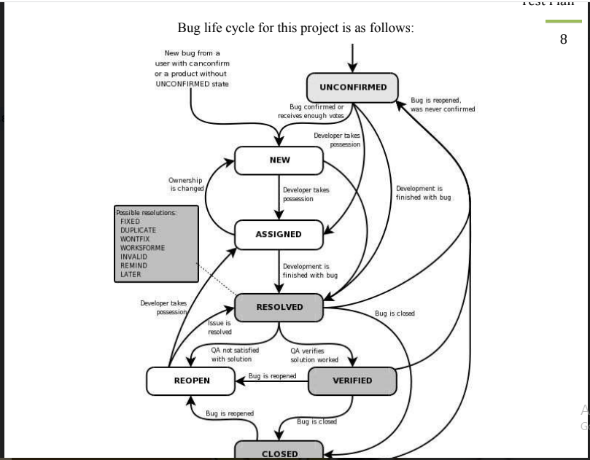

8.3 Testing types
Black box testing:
It is some time called behavioral testing or Partition testing. This kind of testing focuses on
the functional requirements of the software. It enables one to derive sets of input
conditions that that will fully exercise all functional requirements for a program.
GUI Testing:
GUI testing will includes testing the UI part of report. It covers users Report format, look
and feel, error messages, spelling mistakes, GUI guideline violations.
Integration Testing:

Test Plan
9 Integration testing is systematic technique for constructing the program structure while
conducting test to uncover errors associated with interacting. In Report, integration testing
includes the testing Report from respective location(s).
Functional Testing:
Functional testing is carried out in order to find out unexpected behavior of the report. The
characteristic of functional testing are to provide correctness, reliability, testability and
accuracy of the report output/data.
System Testing:
System testing of software is testing conducted on a complete, integrated system to
evaluate the system's compliance with its specified requirements.

8.4 Bug Severity and Priority Definition
Bug Severity and Priority fields are both very important for categorizing bugs and
prioritizing if and when the bugs will be fixed. The bug Severity and Priority levels will
be defined as outlined in the following tables below. Testing will assign a severity level to
all bugs. The Test Lead will be responsible to see that a correct severity level is assigned
to each bug.

Test Plan

10
The QA Lead, Development Lead and Project Manager will participate in bug review
meetings to assign the priority of all currently active bugs. This meeting will be known as
“Bug Triage Meetings”. The QA Lead is responsible for setting up these meetings on a
routine basis to address the current set of new and existing but unresolved bugs.

Severity List
The tester entering a bug into GForge is also responsible for entering the bug Severity.
Defect Severity
Defect severity or Impact is a classification of software defect(bug) to indicate the degree of negative impact on the quality of software.It is the extent to which the defect can affect the software.
For example: If an application or web page crashes when a remote link is clicked, in this case clicking the remote link by an user is rare but the impact of application crashing is severe. So the severity is high but priority is low.
Defect Severity can be of following types:
- Critical
- Major
- Moderate
- Minor
- Trivial(cosmic)
Critical: The defect that results in the termination of the complete system or one or more component of the system and causes extensive corruption of the data. The failed function is unusable and there is no acceptable alternative method to achieve the required results then the severity will be stated as critical.
Major: The defect that results in the termination of the complete system or one or more component of the system and causes extensive corruption of the data. The failed function is unusable but there exists an acceptable alternative method to achieve the required results then the severity will be stated as major.
Moderate: The defect that does not result in the tcomponent of the system and causes extensive corruption of the data. The failed function is unusable and there is no acceptable alternative method to achieve the required results then the severity will be stated as critical.
Major: The defect that results in the termination of the complete system or one or more component of the system and causes extensive corruption of the data. The failed function is unusable but there exists an acceptable alternative method to achieve the required results then the severity will be stated as major.
Moderate: The defect that does not result in the termination, but causes the system to produce incorrect, incomplete or inconsistent results then the severity will be stated as moderate.
Minor: The defect that does not result in the termination and does not damage the usability of the system and the desired results can be easily obtained by working around the defects then the severity is stated as minor.
Cosmetic: The defect that is related to the enhancement of the system where the changes are related to the look and field of the application then the severity is stated as cosmetic.
Defect Priority
Priority defines the order in which we should resolve a defect. Should we fix it now, or can it wait? This priority status is set by the tester to the developer mentioning the time frame to fix the defect. If high priority is mentioned then the developer has to fix it at the earliest. The priority status is set based on the customer requirements.
For example: If the company name is misspelled in the home page of the website, then the priority is high and severity is low to fix it.
Priority can be of following types:
Low: The defect is an irritant which should be repaired, but repair can be deferred until afterwait? This priority status is set by the tester to the developer mentioning the time frame to fix the defect. If high priority is mentioned then the developer has to fix it at the earliest. The priority status is set based on the customer requirements.
For example: If the company name is misspelled in the home page of the website, then the priority is high and severity is low to fix it.
Priority can be of following types:
Low: The defect is an irritant which should be repaired, but repair can be deferred until after more serious defect have been fixed.
Medium: The defect should be resolved in the normal course of development activities. It can wait until a new build or version is created.
High: The defect must be resolved as soon as possible because the defect is affecting the application or the product severely. The system cannot be used until the repair has been done

9 RESOURCE AND ENVIRONMENT NEEDS
9.1 Testing Tools
Process | Tool
Test case creation | Microsoft Excel
Test case tracking | Microsoft Excel
Test case execution | Manual, Selenium
Test case management | Microsoft Excel
Defect management | Microsoft Word
Test reporting | PDF
Check list creating | Microsoft Excel
Project structure | Mind Map (.xmind)

9.2 Configuration Management
x Documents CM: SVN
x Code CM: Git
9.3 Test Environment
x Support level 1 (browsers):
x Windows 8: Edge, Chrome (latest), Firefox (latest), Safari (latest)
x Mac OS X: Chrome (latest), Firefox (latest), Safari (latest)

Test Plan
12 x Linux Ubuntu: Chrome (latest), Firefox (latest)
x Support level 1 (devices):
x iPhone 5 / 6, iPad 3, Nokia Lumia 910, Google Nexus 7, LG G3.
x Support level 2:
x Windows 7: IE 9+, Chrome (latest), Firefox (latest), Safari (latest)
x Windows XP: IE 8, Chrome (latest), Firefox (latest), Safari (latest)
x Support level 3:
x anything else

10 TEST SCHEDULE

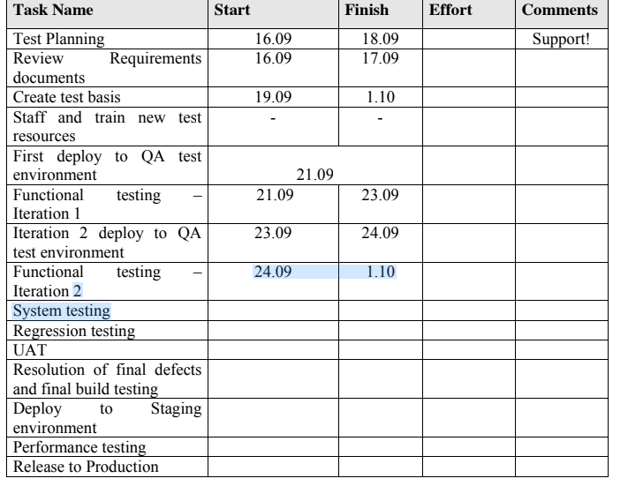

APPROVALS:
 | PROJECT MANAGER | QA LEAD
NAME
SIGNATURE

TERMS/ACRONYMS
The below terms are used as examples, please add/remove any terms relevant to the
document.